Noise Barrier Lifecycle Replacement Project on 1) 14th Street SW and 2) Langriville Drive SW

This memo is intended to provide you information regarding the upcoming Noise Barrier Lifecycle Replacement Project on 1) 14th Street SW and 2) Langriville Drive SW. We are proposing lane closures along both 14th Street & Glenmore Trail to complete these works.

Background
Noise Barriers are engineered noise mitigation structures that create a barrier between major roads and residential areas to reduce noise level for residents. With a design life of approximately 25 years, noise barriers constructed prior to 1992 have exceeded their intended service-life expectations. Visual inspection of these sites has revealed severe deterioration which could potentially result in hazards to pedestrians and motorists, if left untreated.

Construction Impacts on 1) 14th Street SW and 2) Langriville Drive SW
- Construction will occur on weekdays between the hours of 9:00am - 3:00pm (Monday – Friday)
- Some on-street parking in residential areas may be restricted during the daytime – see Attachment 1 map.
- There may be minor disruptions due to increased road noise to residential dwellings directly adjacent to certain routes as existing noise barriers are removed.
- Demolition of the noise barrier along the 1) 14th Street location is tentatively scheduled as early as September 18. Installing piles and erecting new panels will follow shortly afterwards and take approximately 2 months to complete – pending weather conditions. Crews will make efforts to work along the residential side, however; additional lane closures may be required on 14th Street to ensure safe work site practices.
- Demolition of the noise barrier along the 2) Glenmore Trail location is tentatively scheduled for later this fall (mid-November). Installing piles and erecting new panels will take over a month to complete – pending weather conditions.
- Crews will return next Spring (May 2024) to apply protective epoxy coatings to the panels, which will extend their overall life expectancies.

Should there be any construction related inquiries, please do not hesitate to contact the undersigned or alternatively 3-1-1.

Take Care,
Peter Phillips, M.Eng., P.Eng.
Manager of Bridges and Structures
Public Spaces Delivery
The City of Calgary | Mail Code: #8481
C 403.390.0449 | calgary.ca
13th Floor – Andrew Davison
133 6th Avenue SE, Calgary, AB, T2G 4Z1

Attachment 1: Project Locations

- 14th Street SW

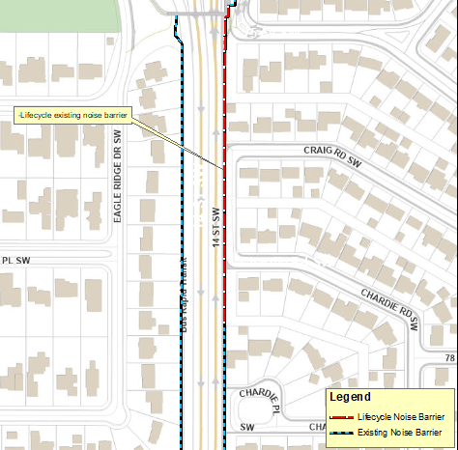
- 1 lane closure on 14th Street SW for approximately a week
- Demolition tentatively scheduled to start September 18th from 9:00am – 3:00pm
- During construction around the pedestrian bridge, we will keep it open and provide flagging for users.
- Sidewalk detour signs will be arranged to redirect pedestrians during construction.
- On street parking along Craig Road SW will be temporarily restricted for the duration of the project.

- Langriville Drive SW

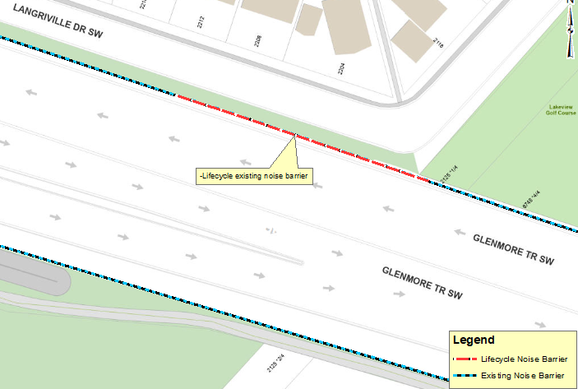
- 1 potential lane closure required for approximately 1 day
- Demolition tentatively scheduled to start mid-November from 9:00am – 3:00pm
- On street parking along Langriville Drive SW will be temporarily restricted for the duration of the project

ISC: Unrestricted

